Roof - 03002 - Lot 2 Carton Road Gordon

Report ID: Roof | Project name: 03002 - Lot 2 Carton Road Gordon | Comment
Roof Cover | Corrugated 0.42, Colorbond | 540.79 m2
Insulation | Insulation, 60mm-R1.3 (18m2 Roll)
Roof Pitch/es (°) | 18.0
Roof Sheeting | 540.79 m2
Safety Mesh | 0.00 m2
Rafter Spacing | 600 mm Ctrs
Gutter Selection | 115 Quad Gutter,Colorbond
Fascia Selection | Metal Fascia (600ctrs),Colorbond
Eave Height/s (mm): | 2700 mm
Downpipes: 0 | Not included ,
Fall Protection: NO | - 0.0 Lm

ASSUMPTIONS:
Assumed Eave Gutter & Box Gutter Size(s) including all relevant accessories.
Assumed all products, profiles and finishes.

EXCLUSIONS:
Excludes Downpipes and roof accessories not mentioned in this report.
Excludes Skylights and other roof penetrations not mentioned in this report.

NOTES:
This is an estimate only.
A site measure is required before Ordering Material.
Please confirm the product, profile and finishes with your client before ordering.
The Roof Wizard 3D Model of this take-off is available upon request at no extra charge.

Category | Item Description | Qty
Straight | COCB42,Corrugated 0.42,Colorbond,0.42 | 540.79 sqm
 | 36/6600, 37/5450, 36/5130, 15/4490, 6/3070. | 709.70 m
Ridge | Roll Top Ridge, Colorbond | 113.60
 | 1/7900, 2/7500, 2/6600, 1/6300, 1/5900, 4/4900, 2/4700, 3/4500, 2/4400, 1/3800, 2/2600, 1/2100, 1/1900, 1/1000.
Valley | Valley 0.55mm 400g 3B, Colorbond | 33.80
 | 3/7500, 1/6600, 1/4700.
Fascia | Metal Fascia (600ctrs), Colorbond | 129.50
 | 3/7200, 1/6600, 1/6500, 4/6200, 1/6100, 2/5900, 3/5800, 2/5300, 2/4700, 1/4100, 2/3500, 1/2300, 1/1300.
Gutter | 115 Quad Gutter, Colorbond | 129.50
 | 3/7200, 1/6600, 1/6500, 4/6200, 1/6100, 2/5900, 3/5800, 2/5300, 2/4700, 1/4100, 2/3500, 1/2300, 1/1300.
Batten | 40mm 0.55 Roof Batten 6.0m, Truecore | 840.00
 | 140/6000.

Category | Item Description | Qty
Accessories | Simple, RB,Fascia Bracket (ea),ZA | 212.00
 | Simple, FIC CB,Fascia Internal Corner (ea),CB | 5.00
 | Simple, FEC CB,Fascia External Corner (ea),CB | 9.00
 | Default, DROP,Drops,ZA | 24.00
 | Default, SC,Snap Clips (ea),ZA | 132.00
 | Default, OS,Overstraps (ea),ZA | 132.00
 | Default, 115QGCI CB,115 Quad Gutter Corner Internal (ea),CB | 5.00
 | Default, 115QGCE CB,115 Quad Gutter Corner External (ea),CB | 9.00
Fasteners | Default, RS50,50mm,Roof Screw,Colorbond | 3244.00
 | Default, BZ50,50mm,Batten Zip,Truecore | 2940.00
Insulation | Anticon, A060R13,Insulation,60mm-R1.3 (18m2 Roll) | 29.00

 | First | Second | Total
Roof Area | 511.70 Sq M | 0.00 Sq M | 511.70 Sq M
Curved Roof Area | 0.00 Sq M | 0.00 Sq M | 0.00 Sq M
Ridge Length | 33.10 M | 0.00 M | 33.10 M
Unused Length | 0.00 M | 0.00 M | 0.00 M
Hip Length | 68.82 M | 0.00 M | 68.82 M
Valley Length | 31.07 M | 0.00 M | 31.07 M
Fascia-Gutter Length | 118.24 M | 0.00 M | 118.24 M
Gutter-Only Length | 0.00 M | 0.00 M | 0.00 M
Fascia-Only Length | 0.00 M | 0.00 M | 0.00 M
Barge Length | 0.00 M | 0.00 M | 0.00 M
Fascia-Side Length | 0.00 M | 0.00 M | 0.00 M
Apron Length | 0.00 M | 0.00 M | 0.00 M
Batten Length | 776.03 M | 0.00 M | 776.03 M
Batten2 Length | 0.00 M | 0.00 M | 0.00 M
Box-Gutter Length | 0.00 M | 0.00 M | 0.00 M
Other Length | 0.00 M | 0.00 M | 0.00 M
Party Wall Length | 0.00 M | 0.00 M | 0.00 M
Parapet Length | 0.00 M | 0.00 M | 0.00 M
Wide Flashing Length | 0.00 M | 0.00 M | 0.00 M
Dry Pan Length | 0.00 M | 0.00 M | 0.00 M
Shell Ends | 9 | 0 | 9
Hip Apexes | 7 | 0 | 7
Roof Volume | 370.93 Cu M | 0.00 Cu M | 370.93 Cu M

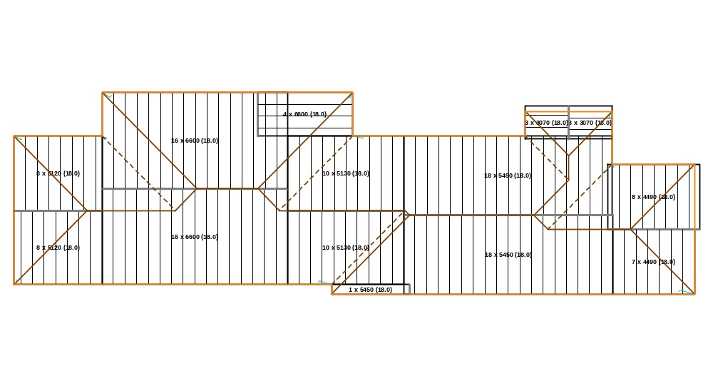
Roof Sheeting Layout
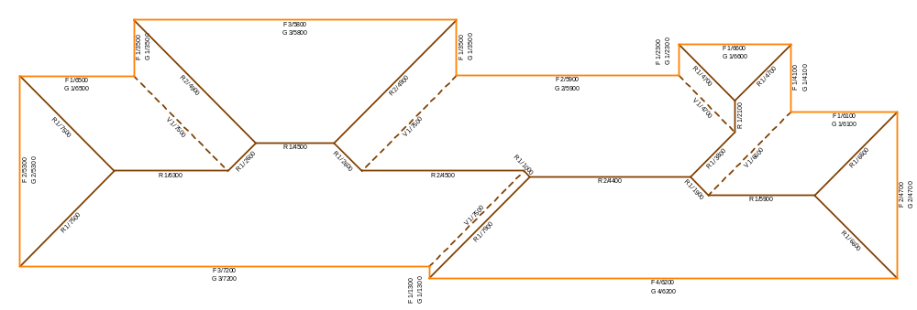
Roof Flashing Layout
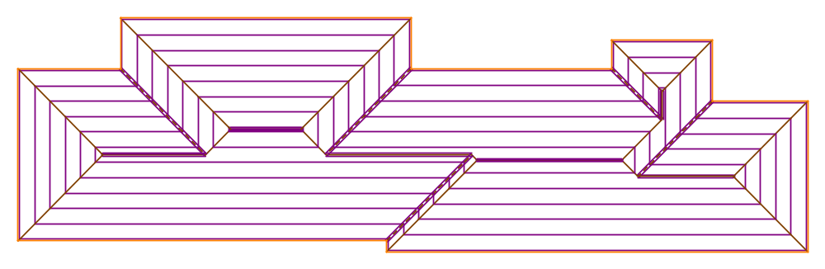
Roof Batten Layout

